1. Update: 15/10/24 Time: 15:56

Dataset size:

* 953 MB
* 500M tokens

1. block_size: int = 512 *# max sequence length*
2. vocab_size: int = 50257 *# number of tokens: 50,000 BPE merges + 256 bytes tokens + 1 <|endoftext|> token*
3. n_layer: int = 4 *# number of layers*
4. n_head: int = 8 *# number of heads*
5. n_embd: int = 512 *# embedding dimension*
6. dropout: float = 0.1
7. total_batch_size = 65536 *# 2**19, ~0.5M, in number of tokens*
8. B = 2 *# micro batch size*
9. T = 256 *# sequence length*
10. max_steps = 1000

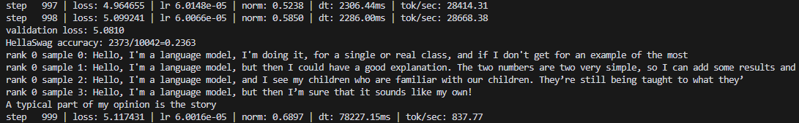

2) Update: 15/10/24 Time: 22:45

Dataset size:

* 953 MB
* 500M tokens

1. block_size: int = 512 *# max sequence length*
2. vocab_size: int = 50257 *# number of tokens: 50,000 BPE merges + 256 bytes tokens + 1 <|endoftext|> token*
3. n_layer: int = 4 *# number of layers*
4. n_head: int = 8 *# number of heads*
5. n_embd: int = 512 *# embedding dimension*
6. dropout: float = 0.1
7. total_batch_size = 65536 *# 2**19, ~0.5M, in number of tokens*
8. B = 4 *# micro batch size*
9. T = 256 *# sequence length*
10. max_steps = 10000

